Смішні Українські Поговорки
Funny Ukrainian Sayings (Humor)

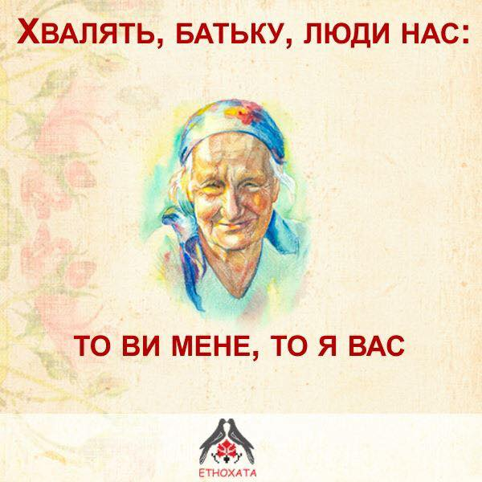
Father, people praise us all the time – you praise me and I praise you!

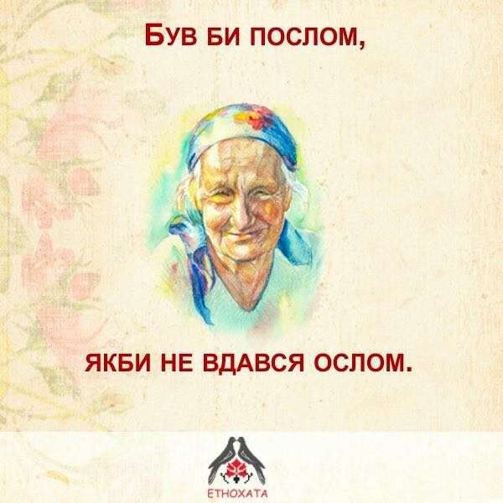
I would become an ambassador, if I wasn’t like a donkey (dumb).
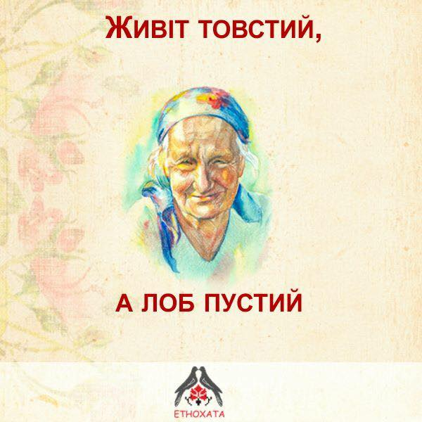
Belly is fat – empty head!

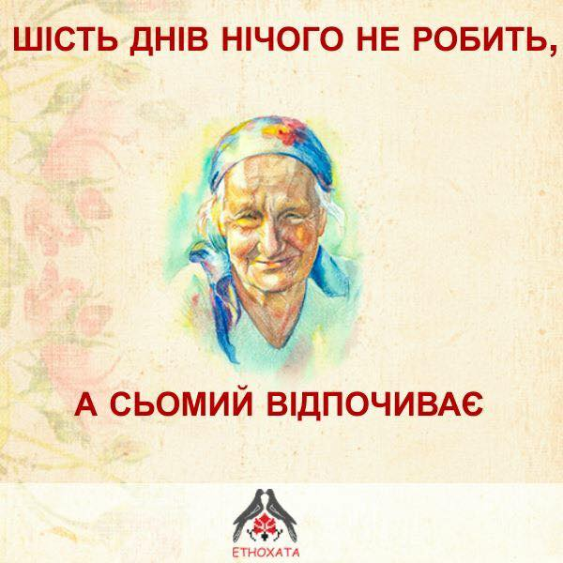
Six days he is doing nothing, and on seventh day – he is resting.
(speaking of a lazy person)

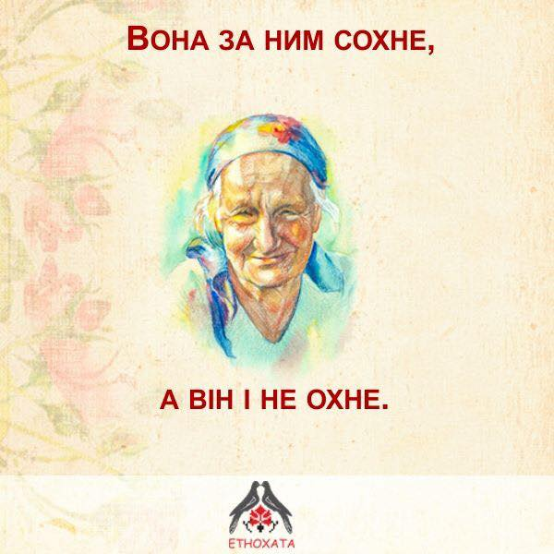
She is crazy about him, but he wouldn’t even say “wow!” (doesn’t care)

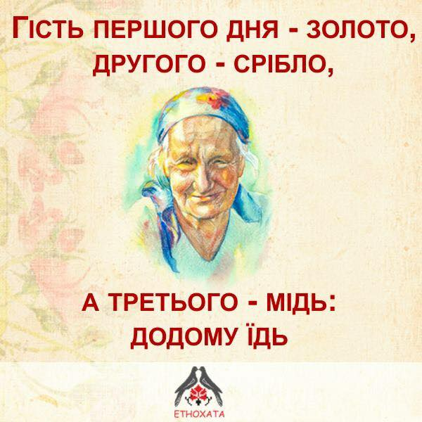
On the first day a guest is a gold, on the second - silver, and on the third – a copper: go home!!

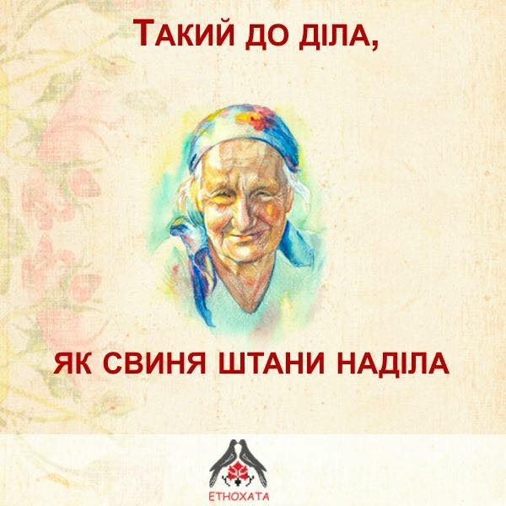
He is as “fine” businessman, as a pig wearing pants!

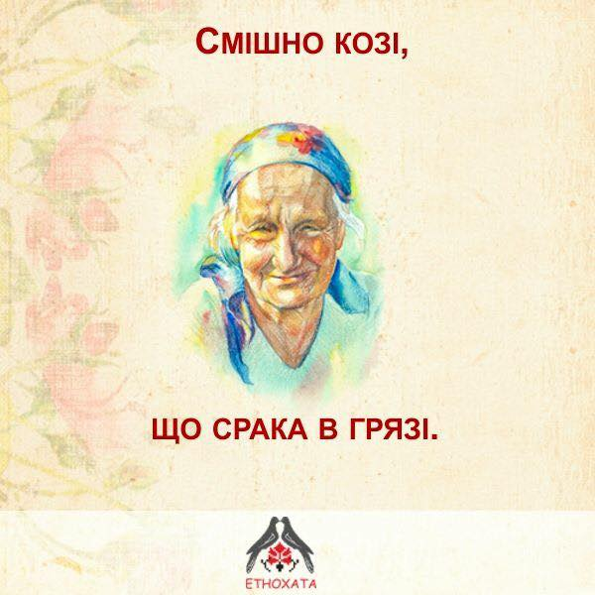
A goat laughs just because her butt is all dirty!
Срака – Ukrainian slang/folk word for “butt”

